Addendum to Application Form

First Name: Sarvesh Last Name: Tawde Applicant ID (if available): 1190567

With reference to the application form that I have submitted earlier on date 25th April 2026 Tech Mahindra Limited and based on the review of the support documentation or the preliminary background verification conducted by Tech Mahindra Limited, I provide the below further particulars.

I hereby also provide consent to Tech Mahindra Limited for re-initiating these checks or re-verify as per applicable process by Tech Mahindra Limited through its agencies.

Particulars of updated/corrected inputs:

1. LWD updation
2. CTC Detail updation

Reason for correction: Received Service letter post LWD & final updated CTC statement.

Signature
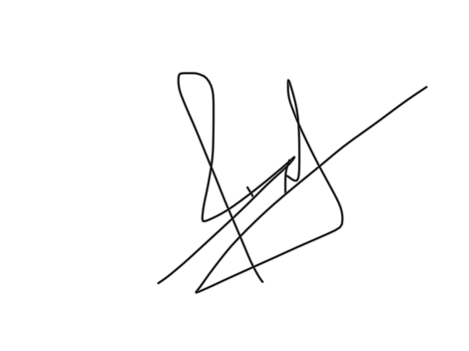
Date*07-05-2026 Place*Mumbai

Tech Mahindra Limited is an Equal Employment Opportunity Employer. It promotes and supports a diverse workforce at all levels in the Company. All qualiﬁed and eligible applicants will receive due consideration for employment without any regard to their race, religion, color, gender, age, nationality, origin or disability. All applicants will be evaluated solely on the basis of their professional ability, competence, and requirement of the essential functions of the positions they have applied for.

